Project Report

# INTRODUCTION

* 1. **Project Overview**

To develop an end-to-end web application capable of displaying the current job openings based on the user skillset. The user and their information are stored in the Database. An alert is sent when there is an opening based on the user skillset. Users will interact with the chatbot and can get the recommendations based on their skills. We can use a job search API to get the current job openings in the market which will fetch the data directly from the webpage.

# Purpose

The main aim of the project is to building a model with a skill recommender solution through which the fresher or the skilled person can log in and find the jobs by using the search option or they can directly interact with the chatbot and get their dream job.

# LITERATURE SURVEY

* 1. **Existing problem**

Skill -based recommendation services platforms wants to turn into a leading source of the job recommender platform. The job and skill recommender system is expected to reduce unemployment and improve the skills of job seekers to boost the country’s economy. Job recommender is giving guidance for job seekers to get quick contact for those jobs. Immediate announcement of the latest job

openings, and walk-in interviews with diﬀerent locations and oﬀers you full details of recruitment such as the number of job vacancies, eligibility criteria, interview date, required qualifications etc.

# Problem Statement Deﬁnition

The main aim of the project is to develop an end-to-end web application capable of displaying the current job openings based on the user skill set. Users will interact with the chat-bot and can get recommendations based on their skills.

This Application uniquely identifies the user’s skills recommend the job according to the user’s

interest.

# IDEATION & PROPOSED SOLUTION

* 1. **Empathy Map Canvas**

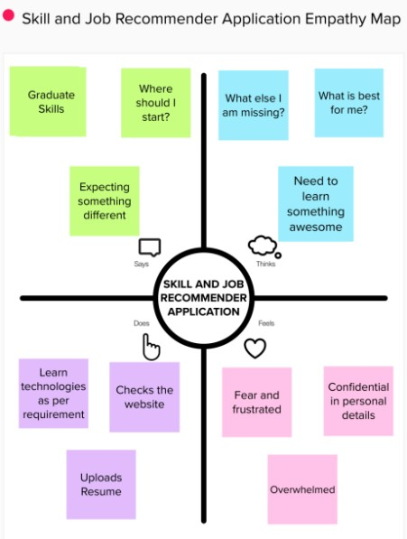

# Ideation & Brainstorming

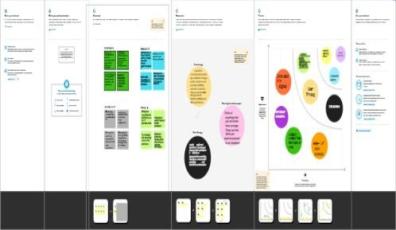

* 1. **Proposed Solution**

# S.No. Parameter Description

1. Problem Statement (Problem to

be solved)

Every industry has a lot of career opportunities, but job seekers are unaware of them. The unemployability crisis can be solved

if every job seeker receives the right career guidance and proper job role training. So, to eradicate the unemployment crisis, for the job seekers to find a job they desire, match their qualifications and skills.

1. Idea / Solution description To develop an end-to-end web application capable of displaying the current job openings based on the user skill set. Users will interact with the chat-bot and can get recommendations based on their skills.
2. Novelty / Uniqueness This Application uniquely identifies the user’s skills recommend the job according to the user’s interest.
3. Social Impact / Customer

Satisfaction

1. Business Model

(Revenue Model)

The job and skill recommender system is expected to reduce unemployment and improve the skills of job seekers to boost the country’s economy. The customer satisfaction can be measured by customer loyalty and customer

reviews after deployment of the project. A subscription model can be provided for both employees and employers with additional costs for features along with recurring monthly or

yearly costs.

1. Scalability of the Solution It is lifelong recommender app. Once the user has login to this application, he will be notified about the job up to date.

# Problem Solution ﬁt

The Problem-Solution Fit simply means that you have found a problem with your customer and that the solution you have realized for it actually solves the customer’s problem. It helps entrepreneurs, marketers and corporate innovators identify behavioral patterns

# Purpose:

* + Solve complex problems in a way that fits the state of your customers.
  + Succeed faster and increase your solution adoption by tapping into existing mediums and channels of behavior.
  + Sharpen your communication and marketing strategy with the right triggers and messaging.
  + Increase touch-points with your company by finding the right problem-behavior fit and building trust by solving frequent annoyances, or urgent or costly problems.

# REQUIREMENT ANALYSIS

* 1. **Functional Requirement**

# S. FUNCTIONAL REQUIREMENT

**No (Epic)**

# SUB REQUIREMENT (Story)

1. 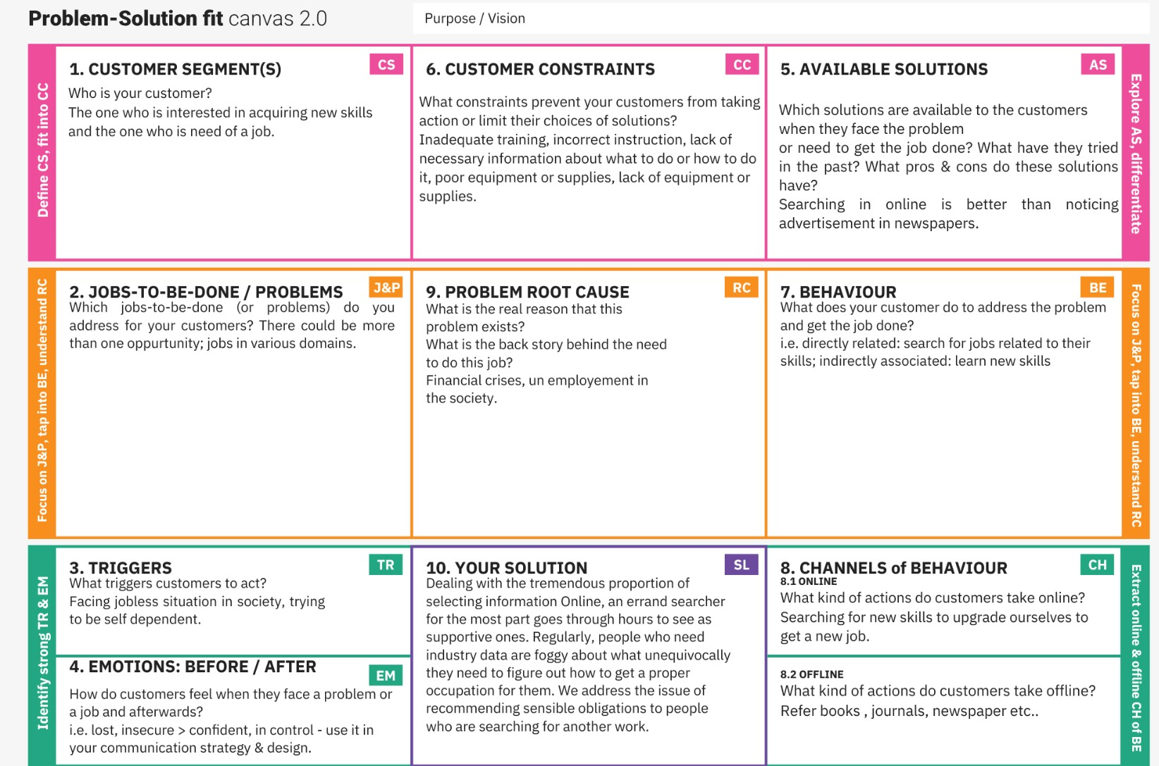Sign In / Login Register with username, password
2. Profile Registration Register with username, password, email, qualification, skills. This data will be stored in a database.
3. Job profile display Display job profiles based on availability, location ,skills
4. Chatbot A chat on the webpage to solve user queries and issues
5. Job registration A copy of the company the user applied for with its registration/description details will be sent to the registered email id.
6. Logout Logging out of the webpage.

# Non-Functional requirements

|  |  |  |
| --- | --- | --- |
| **S. No** | **NON-FUNTIONAL REQUIREMENT** | **DESCRIPTION** |
| 1) | Usability | The webpage will be designed in such a way that any non-technical user can easily navigate through it and complete  the job registration work. |
| 2) | Security | Using of SSL certificate (Python Flask to Cloud connect) will provide security to the project. Database will be safely stored in DB2. |
| 3) | Reliability | To make sure the webpage doesn’t go down due  to network traffic. |
| 4) | Performance | Focus on loading the webpage as  quickly as possible irrespective of the number of user/integrator traffic. |
| 5) | Availability | This webpage will be available to all  users at any given point of time. |
| 6) | Scalability | Increasing the storage space of database can increase  the number of users. |

1. **PROJECT DESIGN**

# Data Flow Diagram

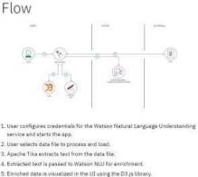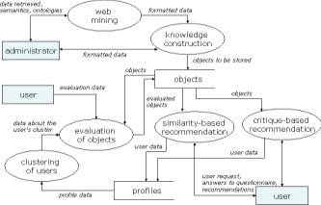

* 1. **Solution & Technical Architecture**

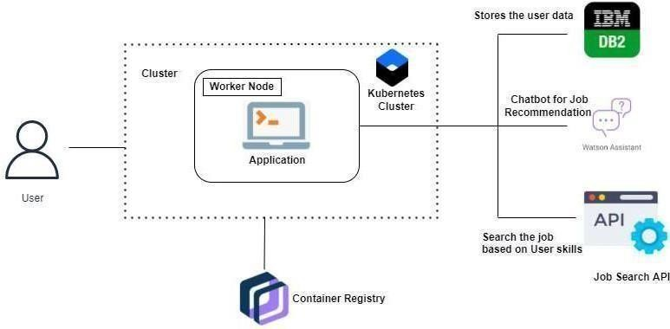

|  |  |  |
| --- | --- | --- |
| **S.No.** | **Parameter** | **Description** |
| 1. | Is the System Robust? | Yes, it is partially buildable platform as the budget required will be more as cloud is a pay per use model and time taken will be quite. |
| 2. | Is it highly modifiable? | Indeed, the framework is modifiable and it can own up to the progressions by recognizing blunders that requirements  to be fixed and new functionalities. It is exceptionally receptive to the progressions. |
| 3. | Is it Scalable? | Indeed, the framework proposed is exceptionally versatile as it can deal with the developing responsibility where great execution is likewise expected to eﬀectively work. Organization of the stage has been finished utilizing diﬀerent OS virtualization stage it will deal with the responsibility genuinely. |

# User Stories

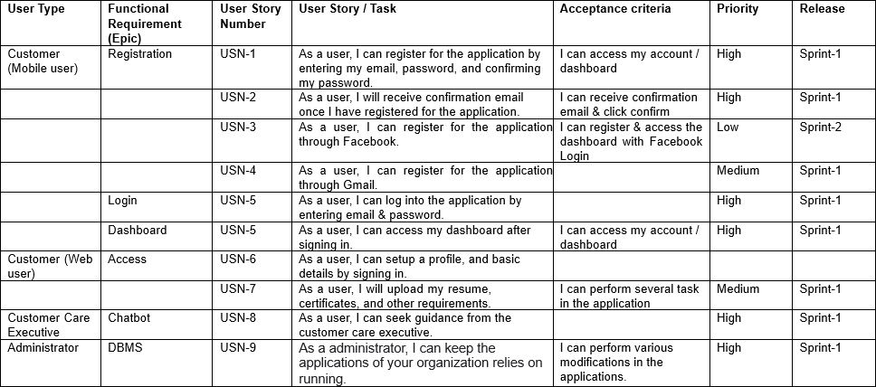

1. **PROJECT PLANNING & SCHEDULING**

# Sprint Planning & Estimation

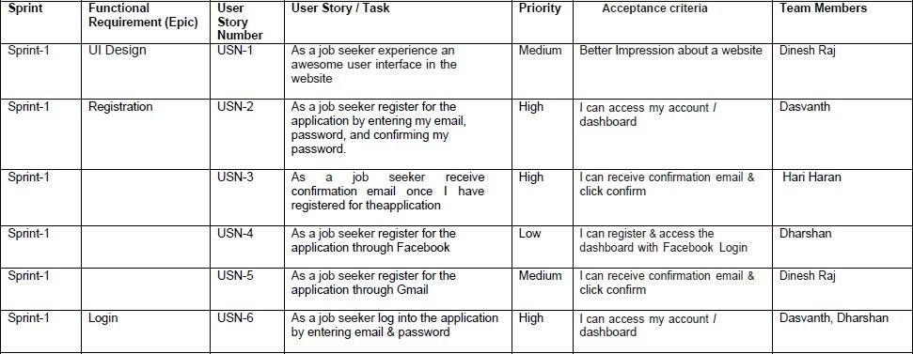

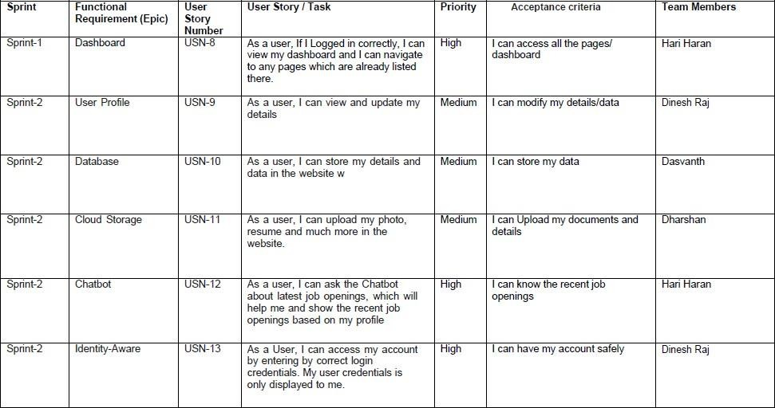

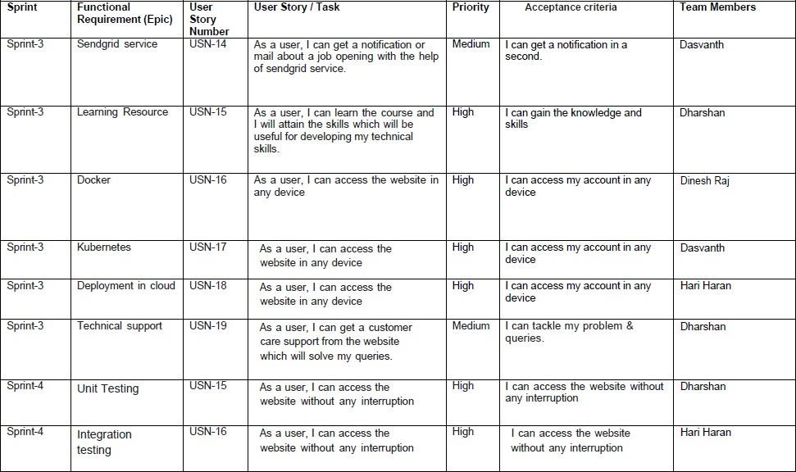

* 1. **Sprint Delivery Schedule**

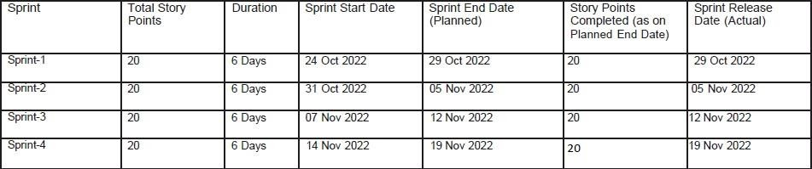

# CODING & SOLUTIONING (Explain the features added in the project along with code)

* 1. **Feature 1**

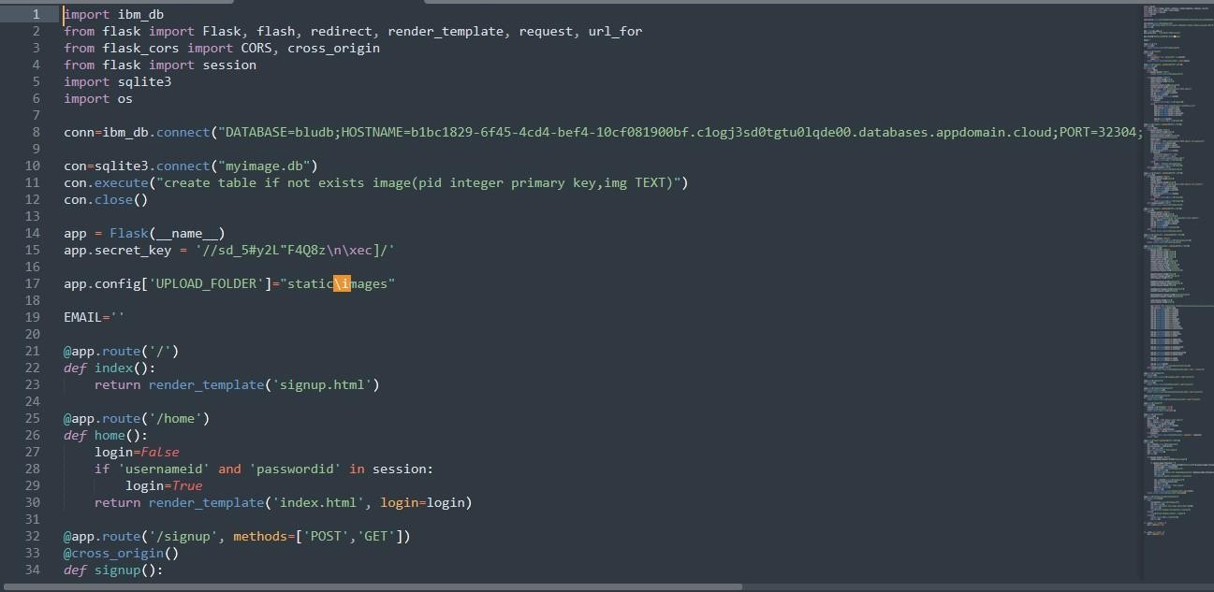

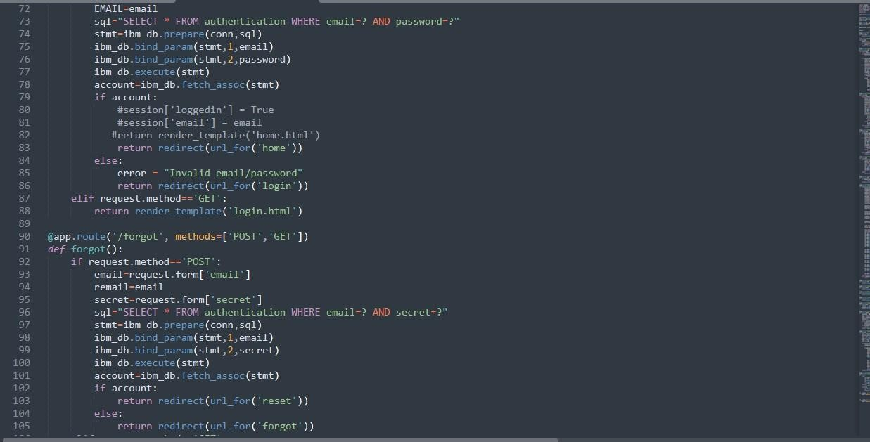

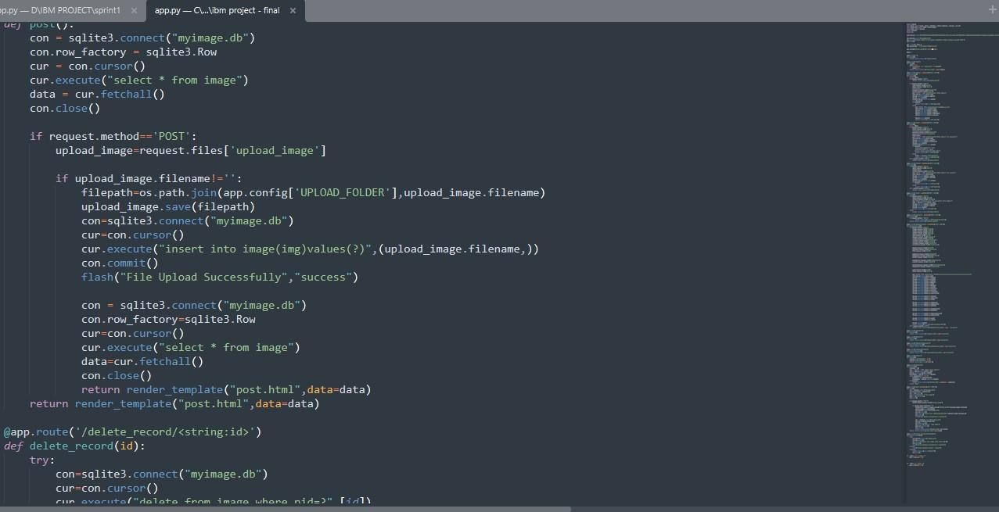

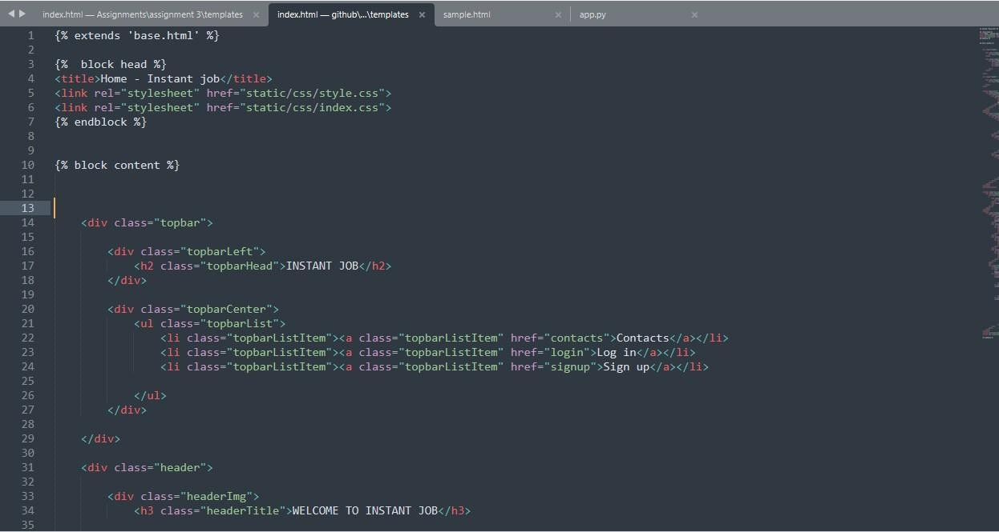

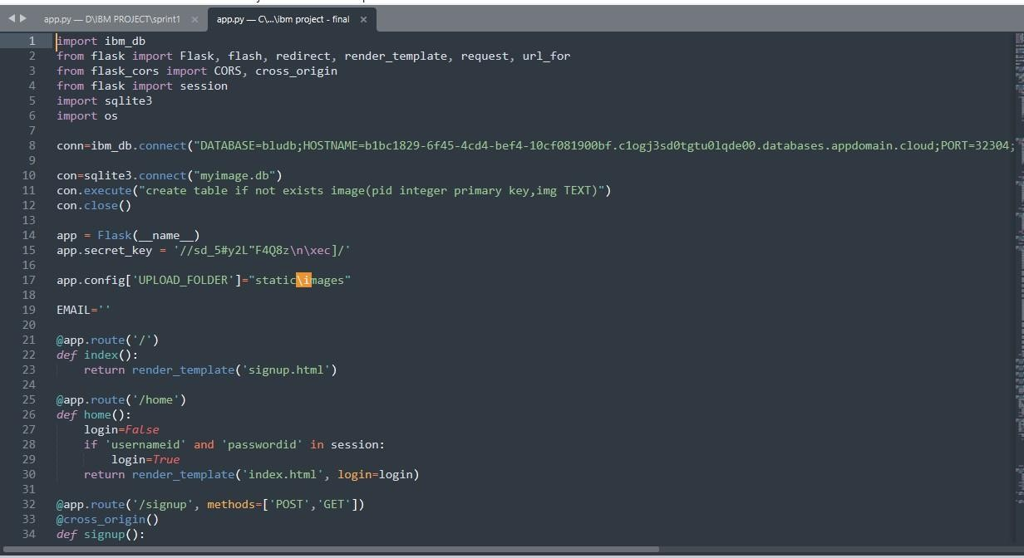

# Feature 2

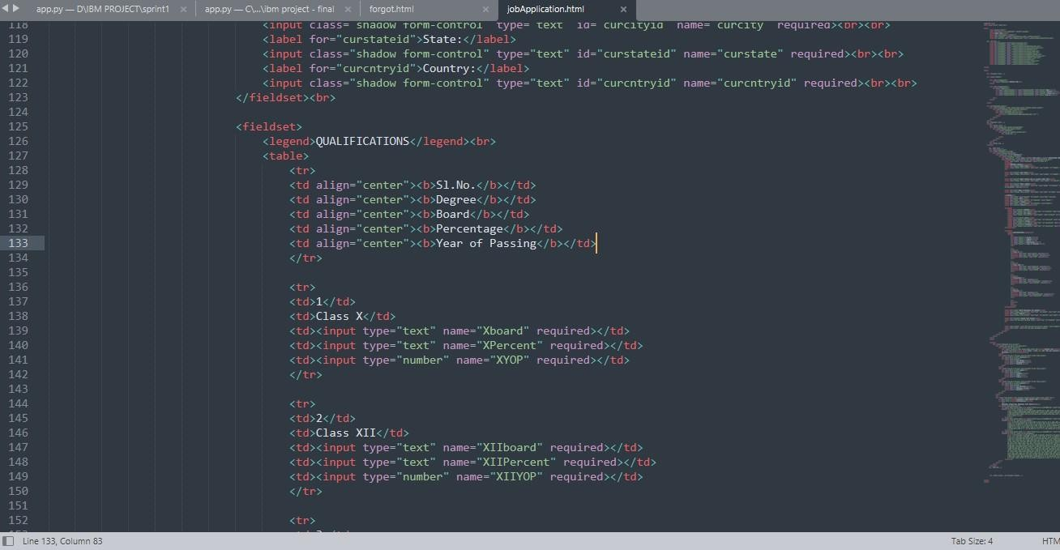

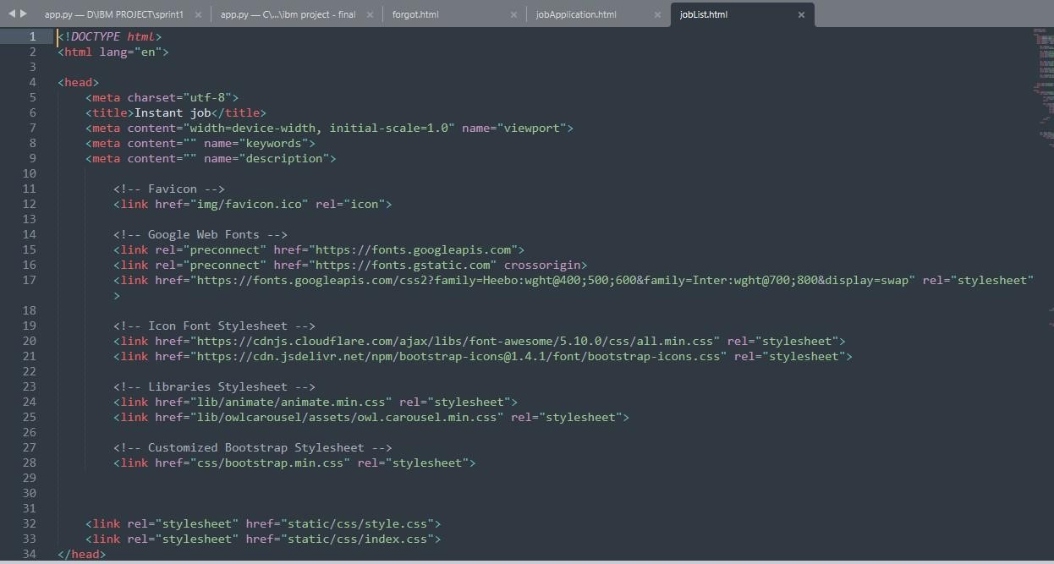

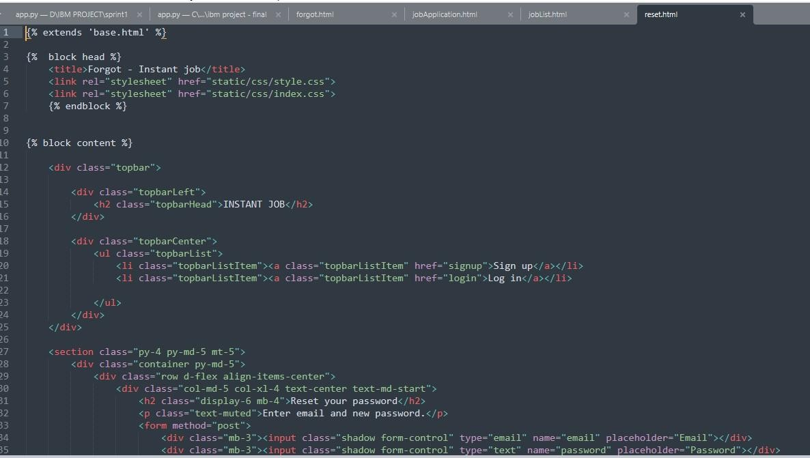

1. **TESTING**

# Test Cases

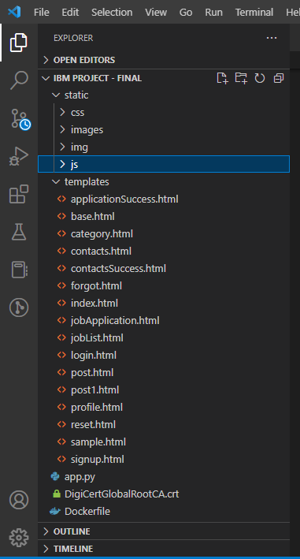

* 1. 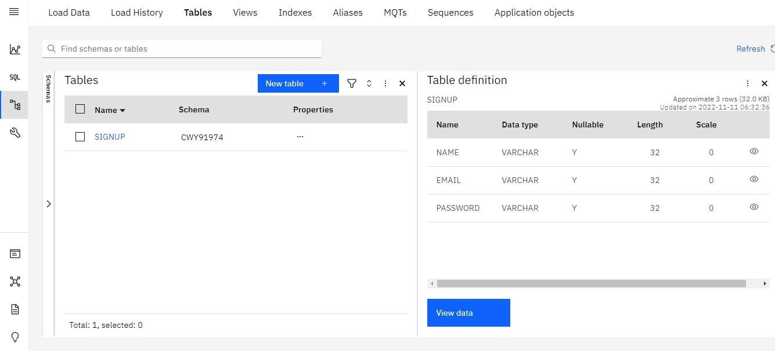**User Acceptance Testing**

# RESULTS

* 1. **Performance Metrics**

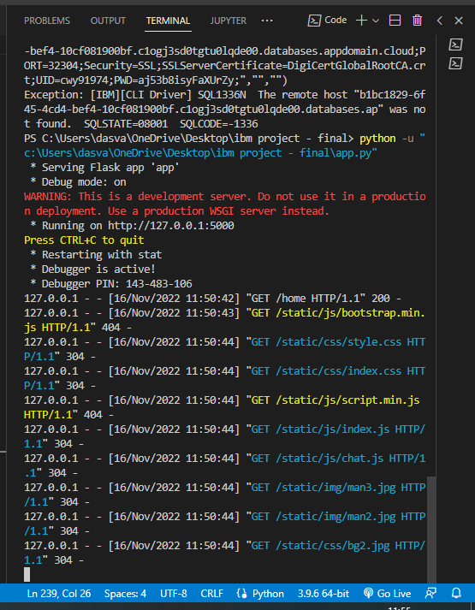

# Output

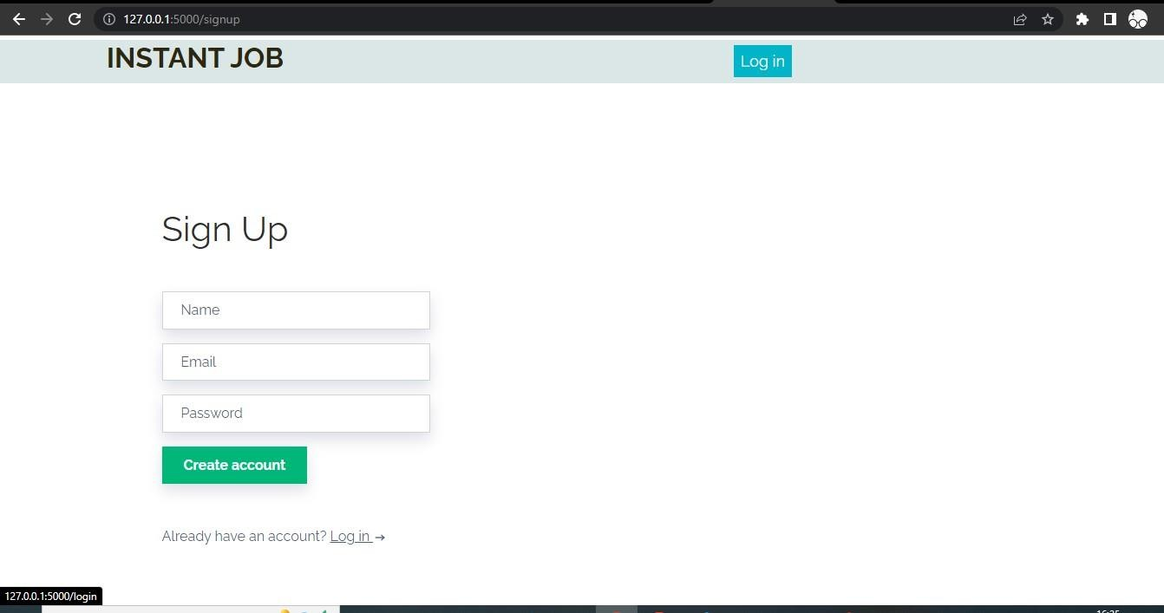

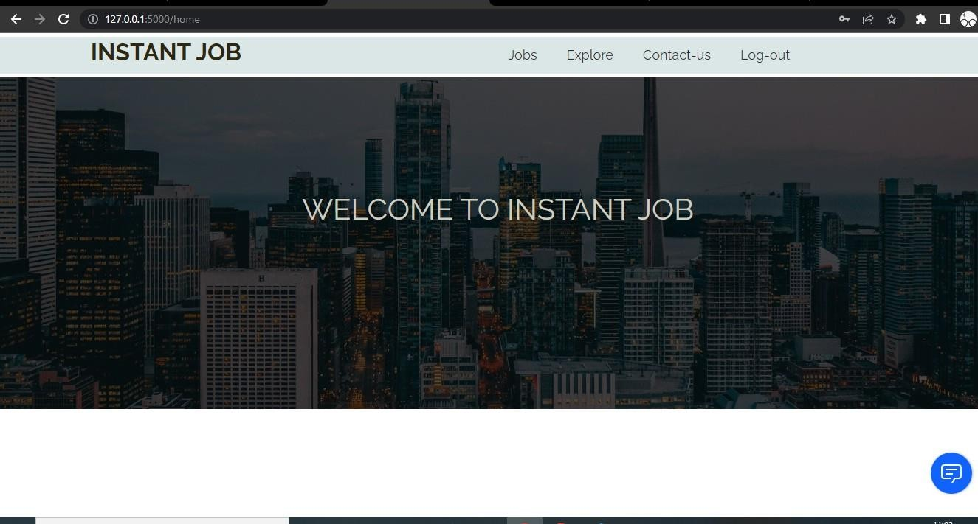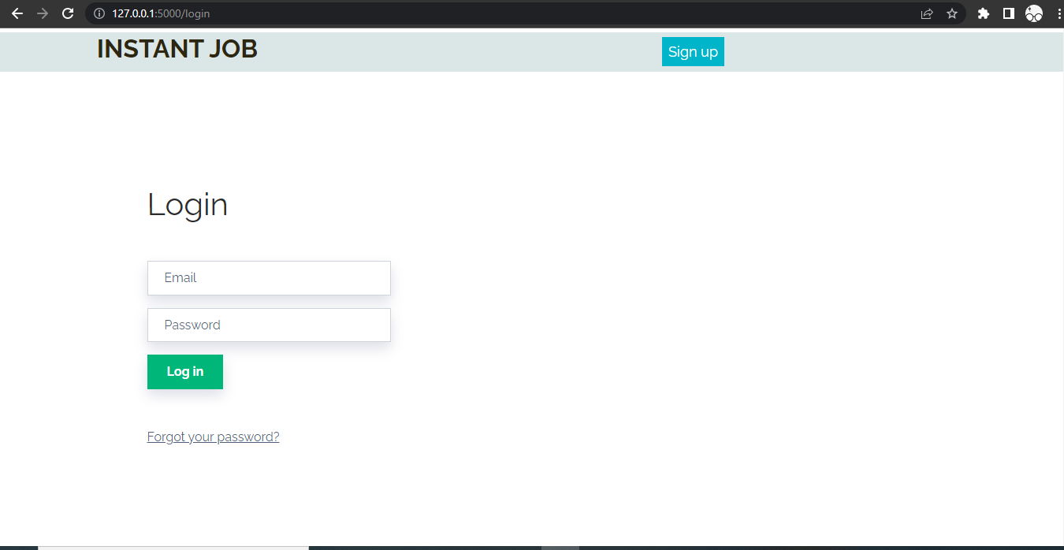

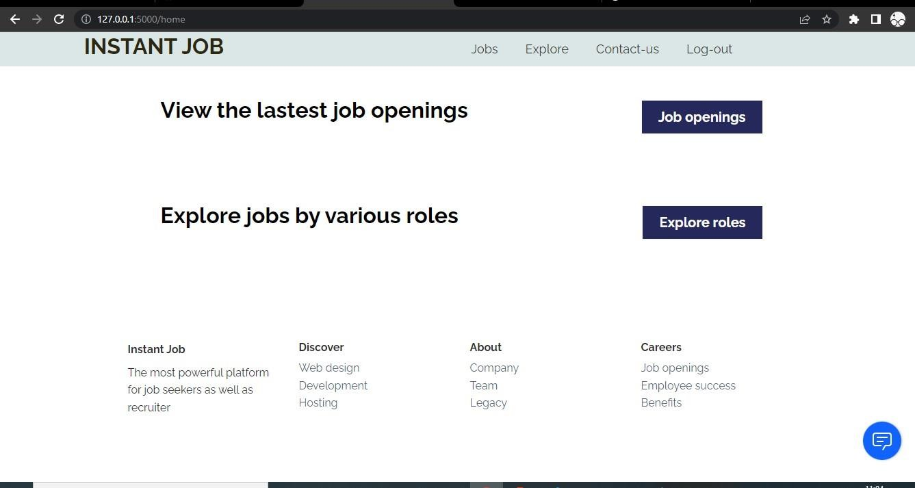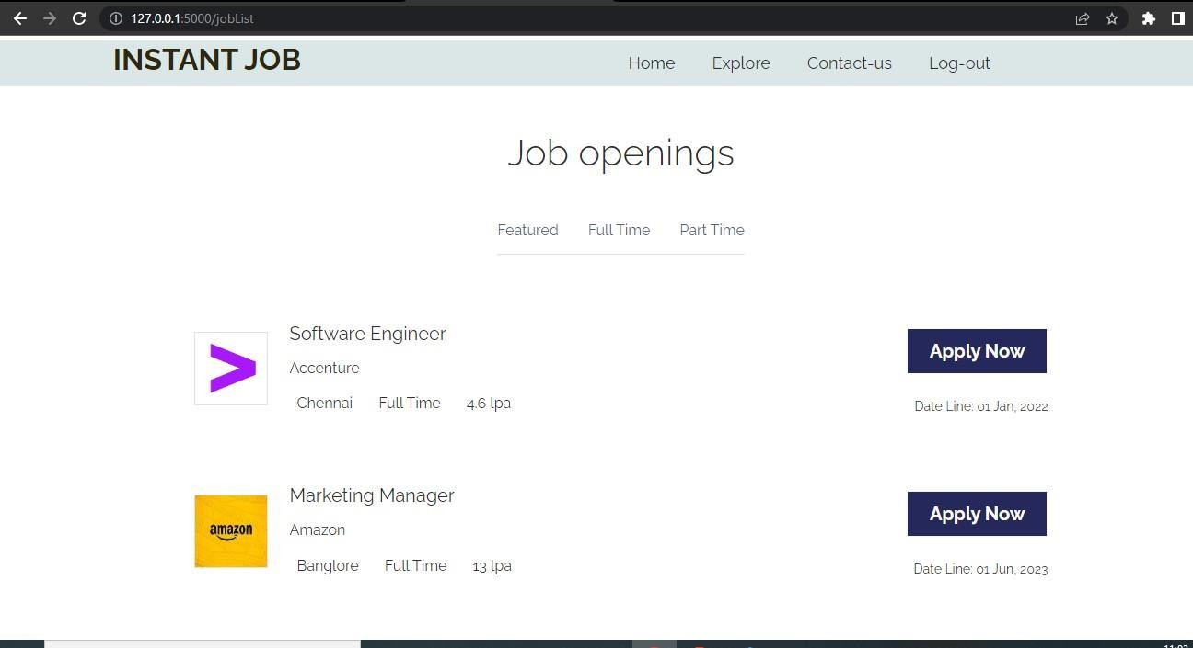

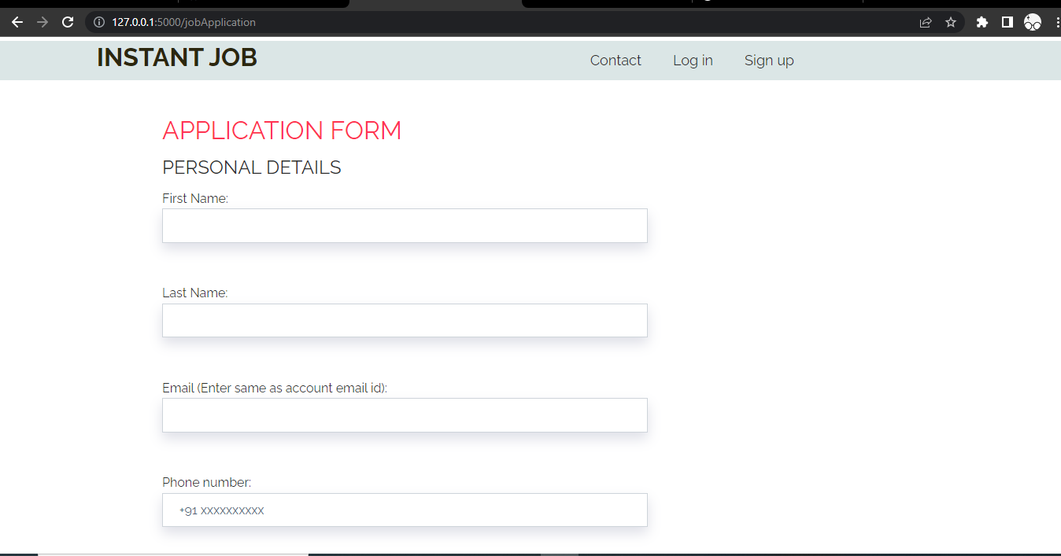

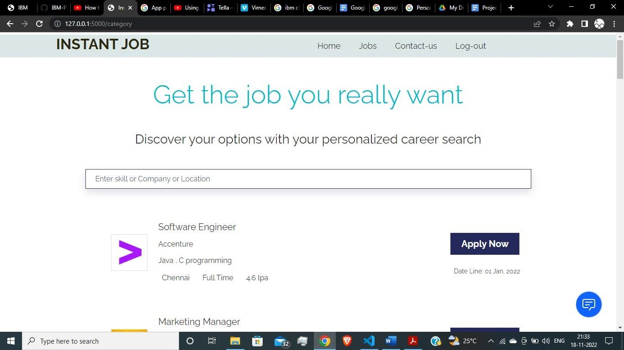

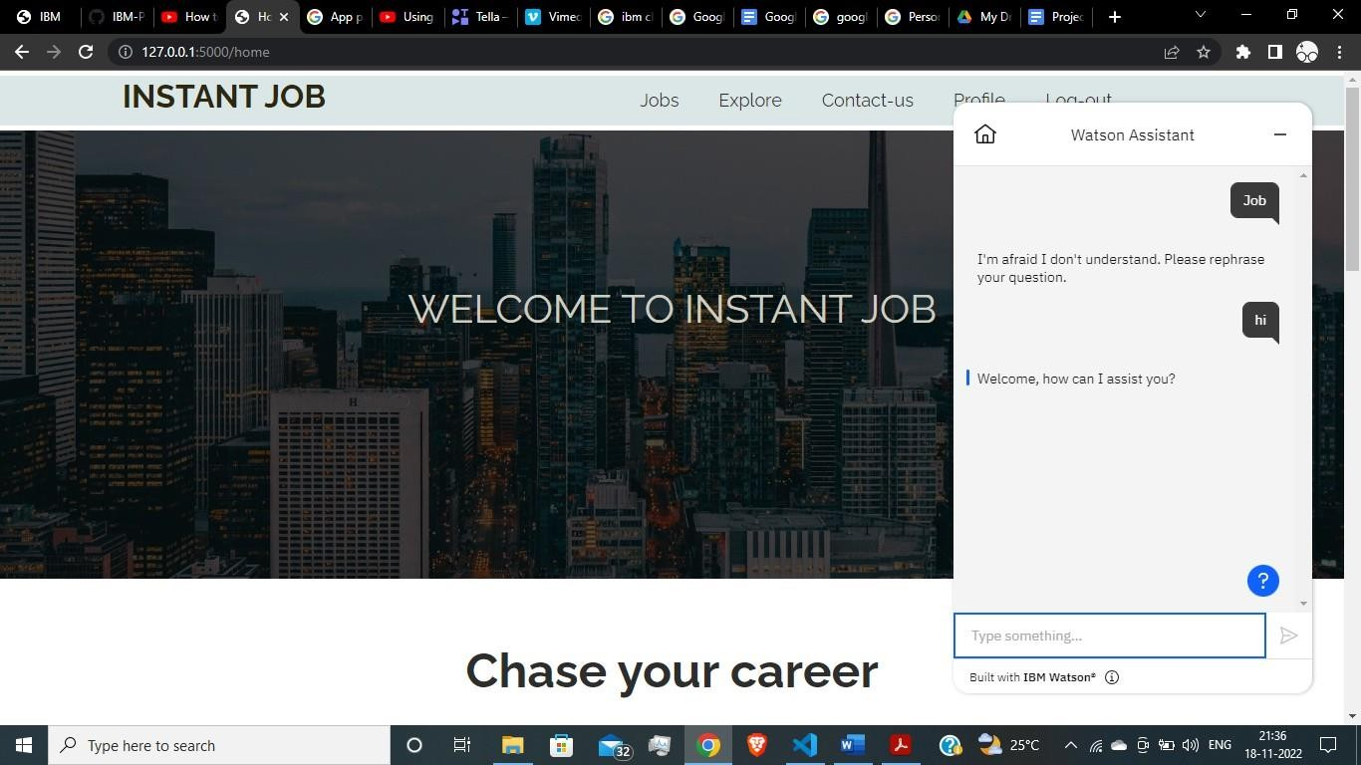

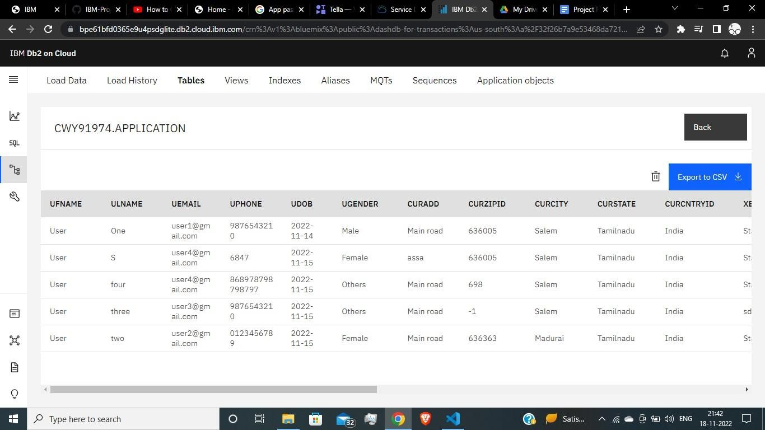

1. **ADVANTAGES & DISADVANTAGES**

# ADVANTAGES

* When recruiting externally, hiring teams find candidates, evaluate them and, if all goes well, persuade them to join their company. All of which takes time.
* Everyone needs some time to adjust to a new role, but internal hires are quicker to onboard than external hires.
* May be familiar with people in their new team, especially in smaller businesses.
* Know how your company operates and most of your policies and practices.

# DISADVANTAGES

* Employees who were considered for a role could feel resentful if a colleague or external candidate is eventually hired.
* While your company may have a lot of qualified candidates for specific positions, this isn’t

necessarily true for every open role.

# CONCLUSION

By the end of this project we will

* know fundamental concepts and techniques of recommender system.
* gain a broad understanding of databases and cloud.
* know how to build a web application using the Flask framework.
* know how to build chatbot.
* know how to containerize the application.

# FUTURE SCOPE

* AI is revolutionizing the recommender systems.
* The popularity of LinkedIn and Google for jobs has proved that there is a future for job boards if

eﬀectively managed to provide solutions

* Right pricing strategies for online recruitment advertising are essential to get an eﬀective

response.

* Recruiters and job seekers are experiencing an entirely automated process of searching and connecting. All job boards should be perfectly indexed, highly responsive, and exhaustive in job descriptions to establish their credibility and reliability.

# APPENDIX

Ref: [https://github.com/IBM-EPBL/IBM-Píoject-40069-1660622812](https://github.com/IBM-EPBL/IBM-Project-40069-1660622812)